**SCREENSHOTS**

**1)Doctor Module**

**Home Page**

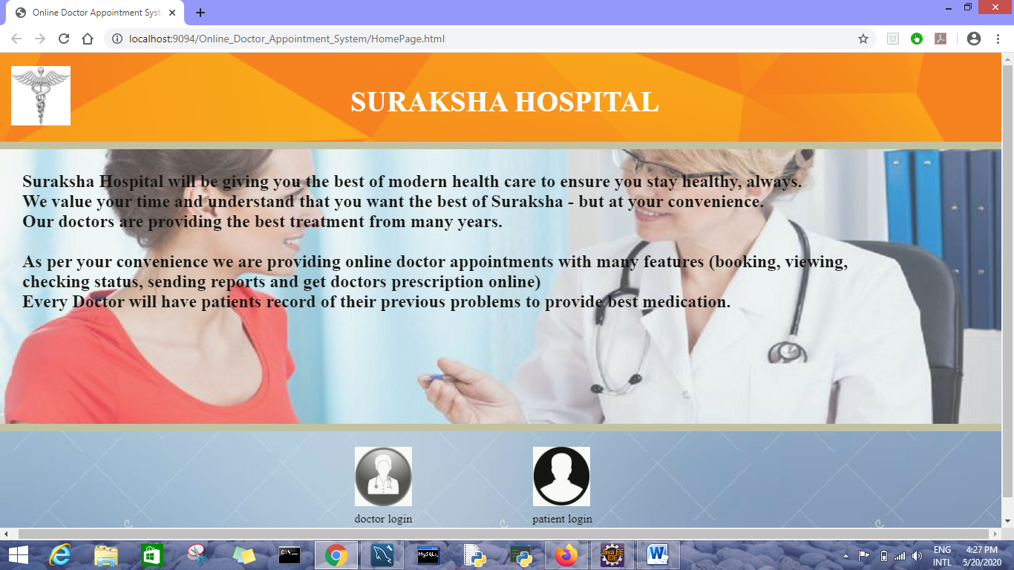

**Doctor Login Page**

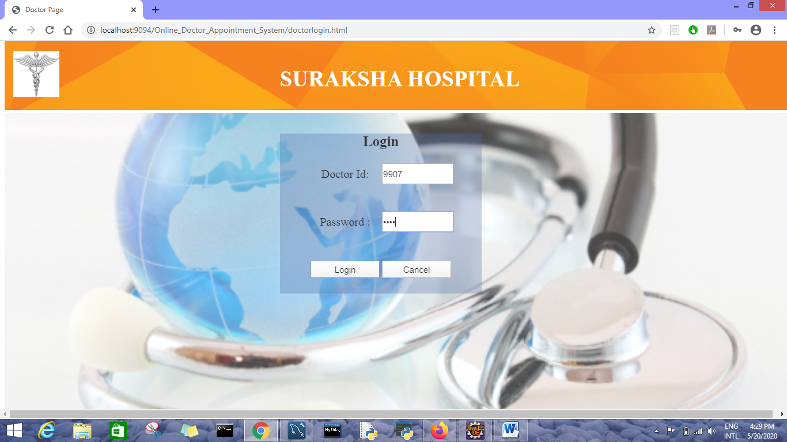

**Doctor Portal Page**

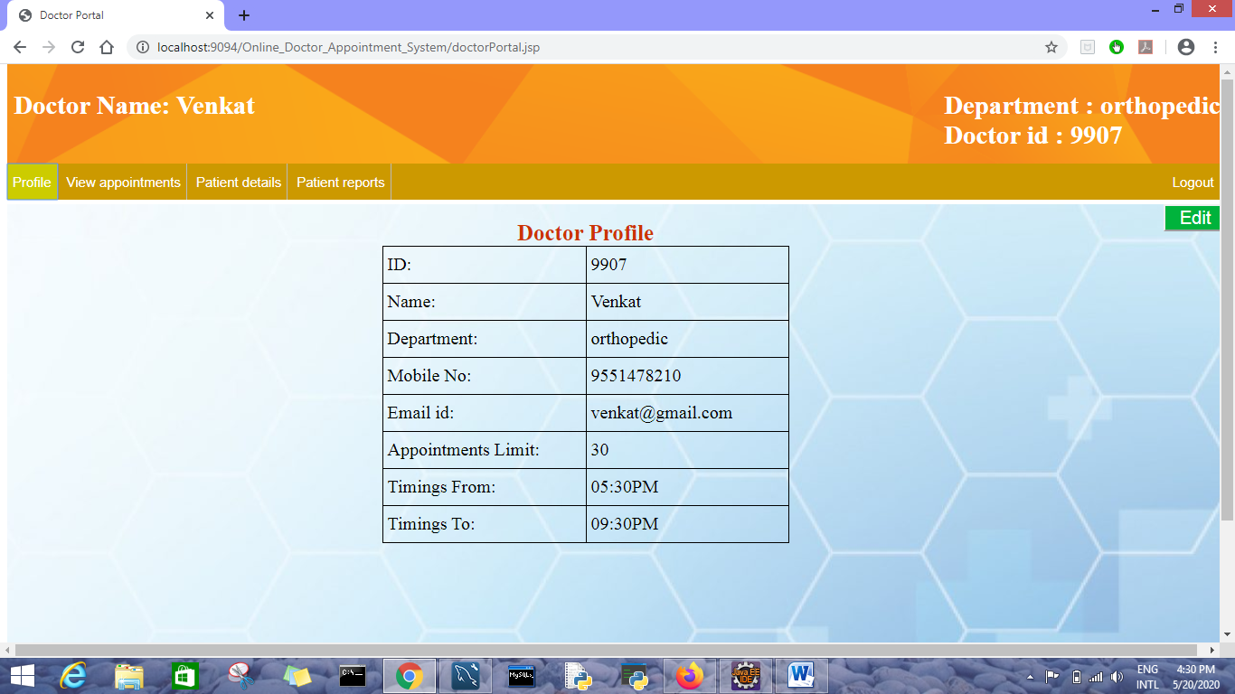

**Doctor Profile Editing Page**

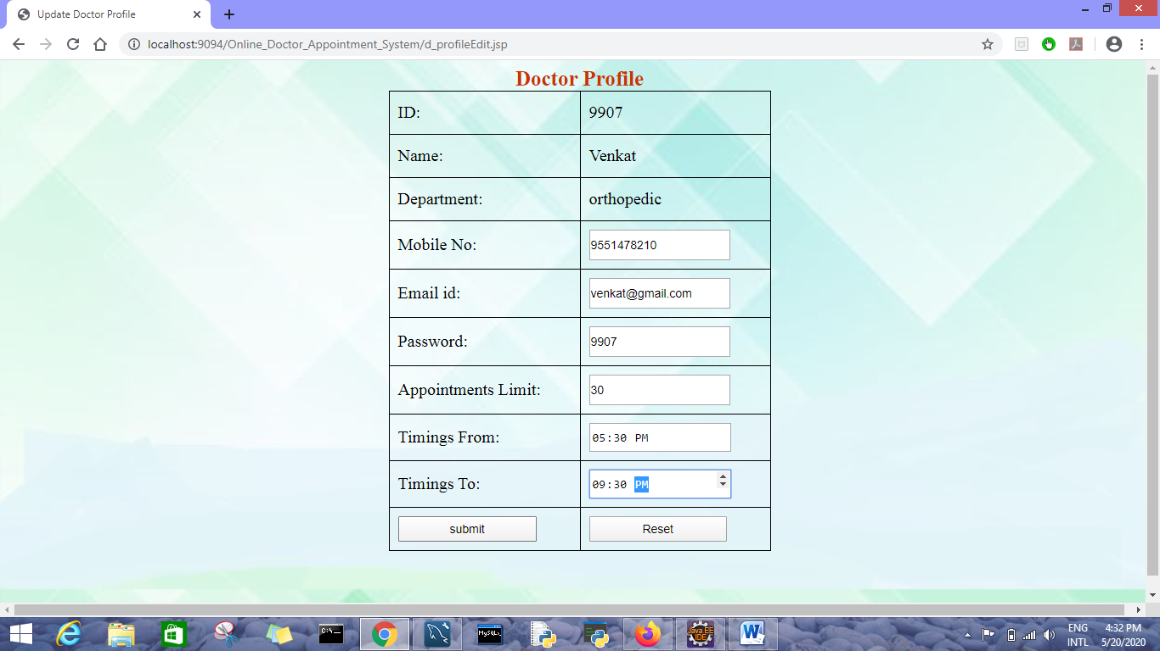

**Confirmation message of profile updation:**

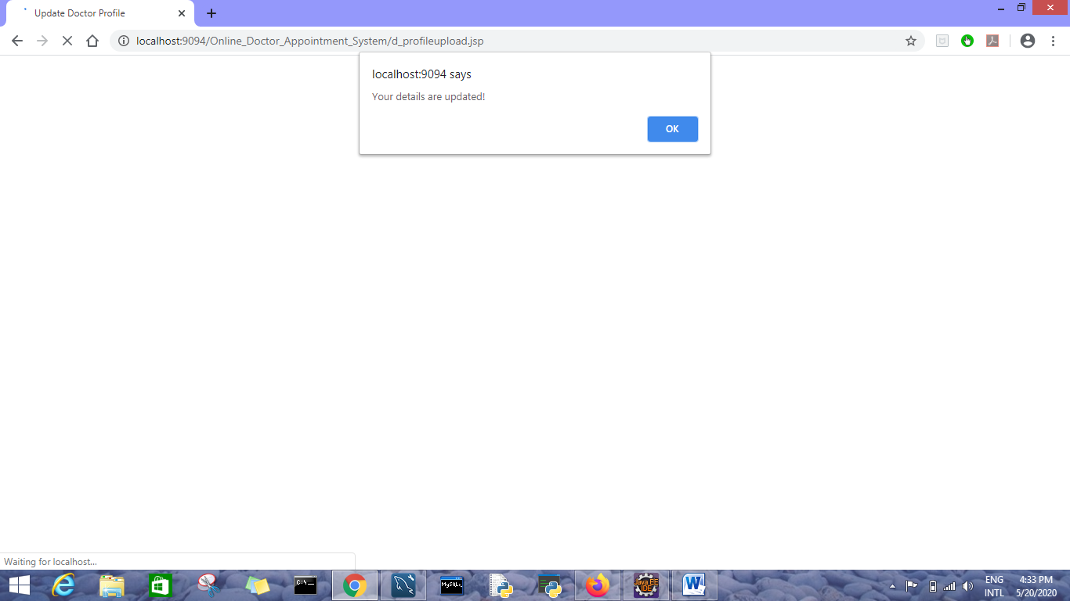

**Viewing all appointments in Doctor Portal**

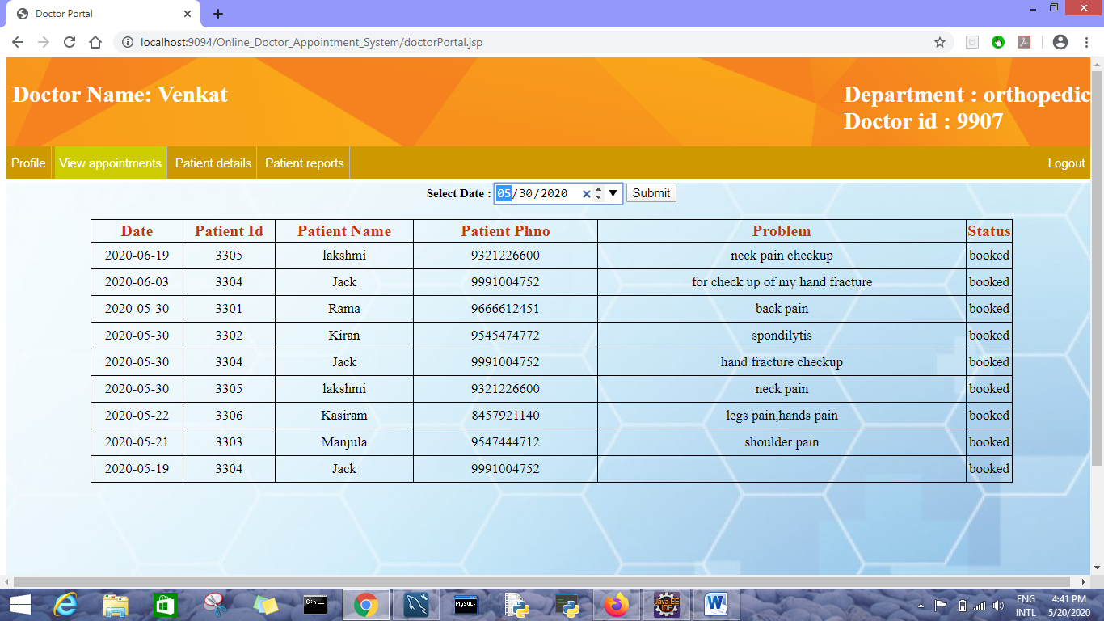

**View appointments of specific date**

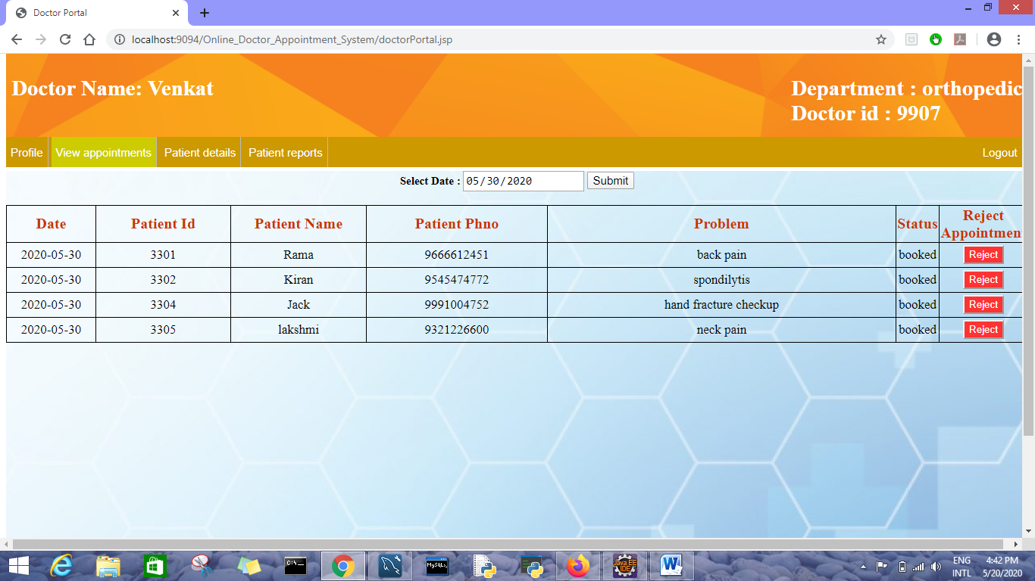

**Confirmation message to reject an appointment**

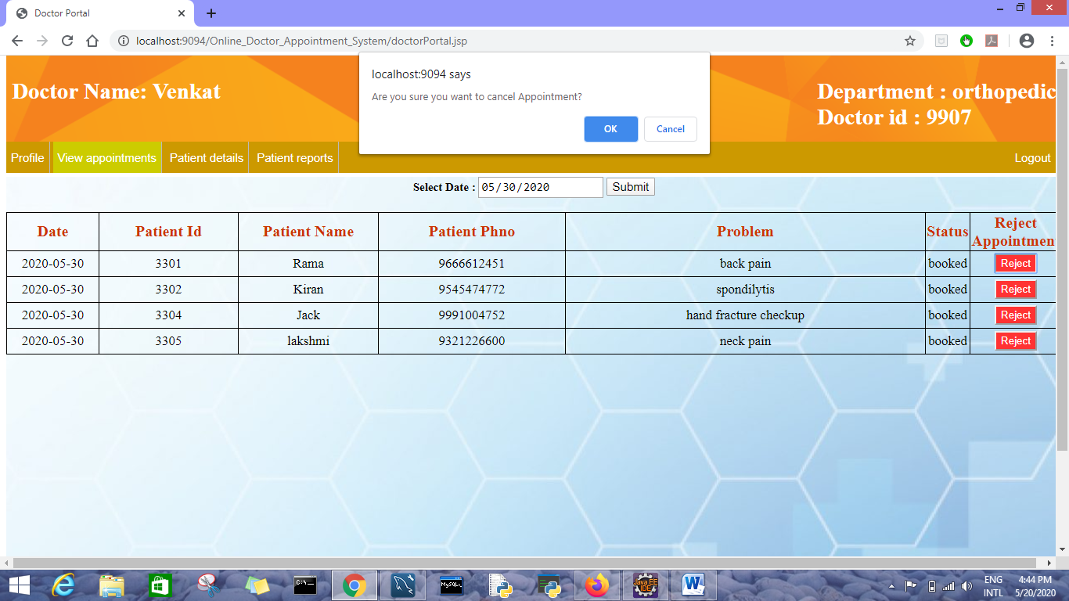

**Entering registered patient’s ID to view his details**

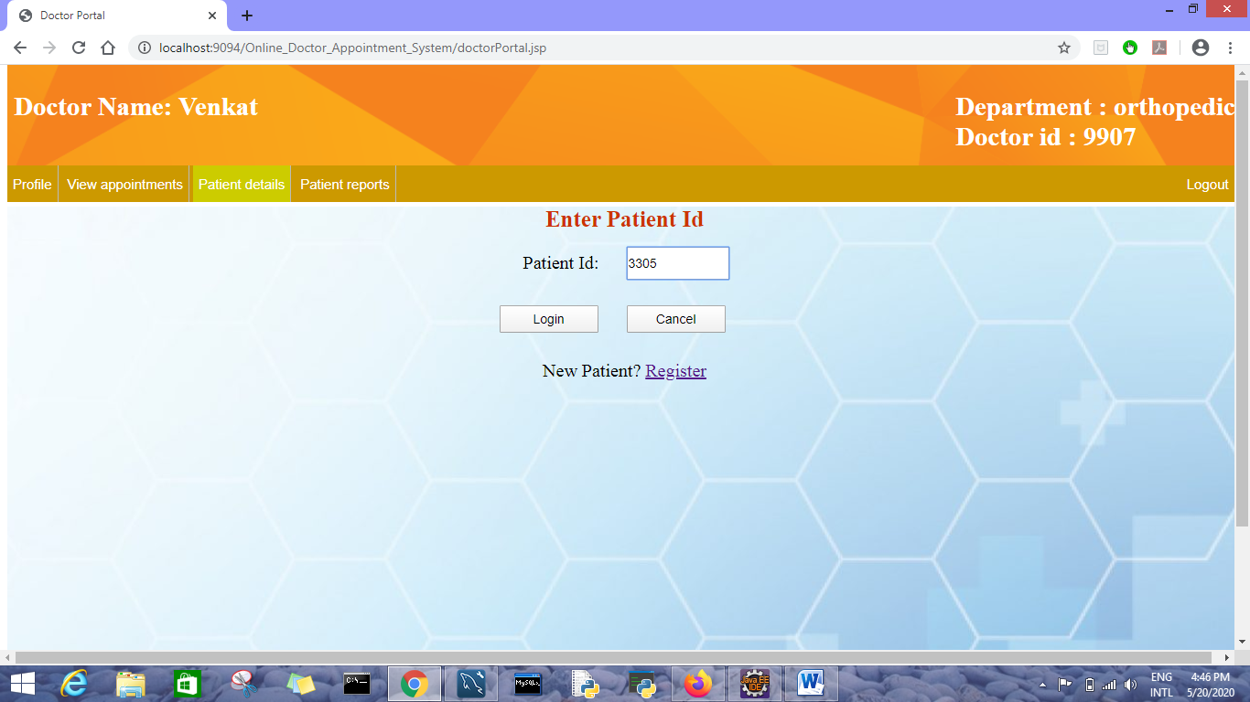

**Registering new patient with their ID**

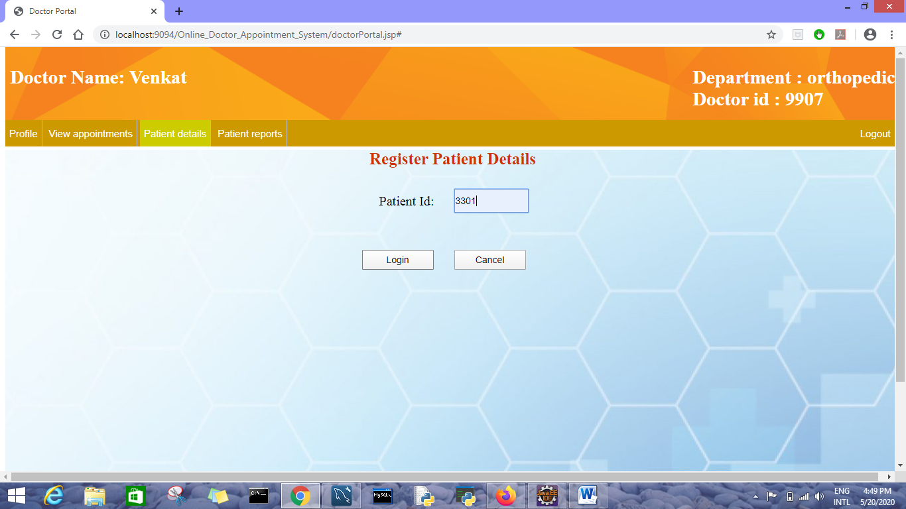

**Registered Patient details shown as follows**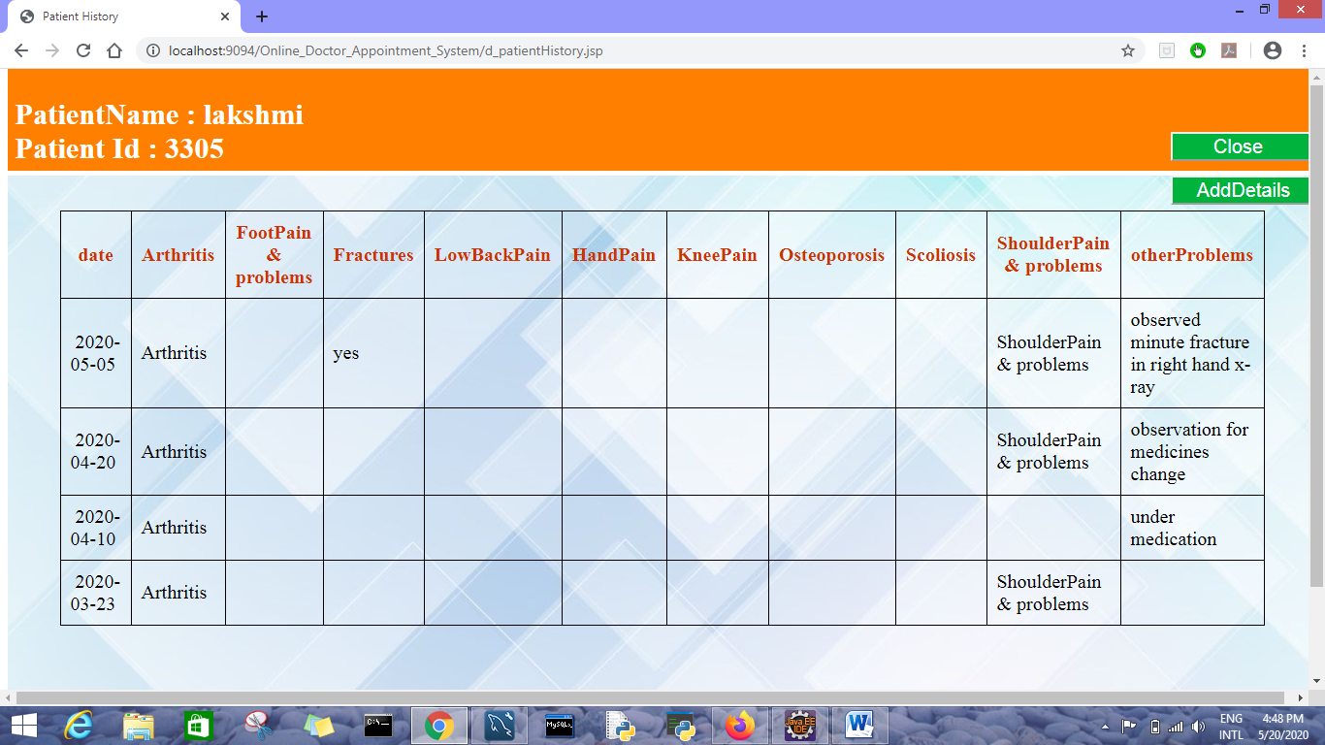

**Orthopedic Doctor catalogue when clicks on Add details button**

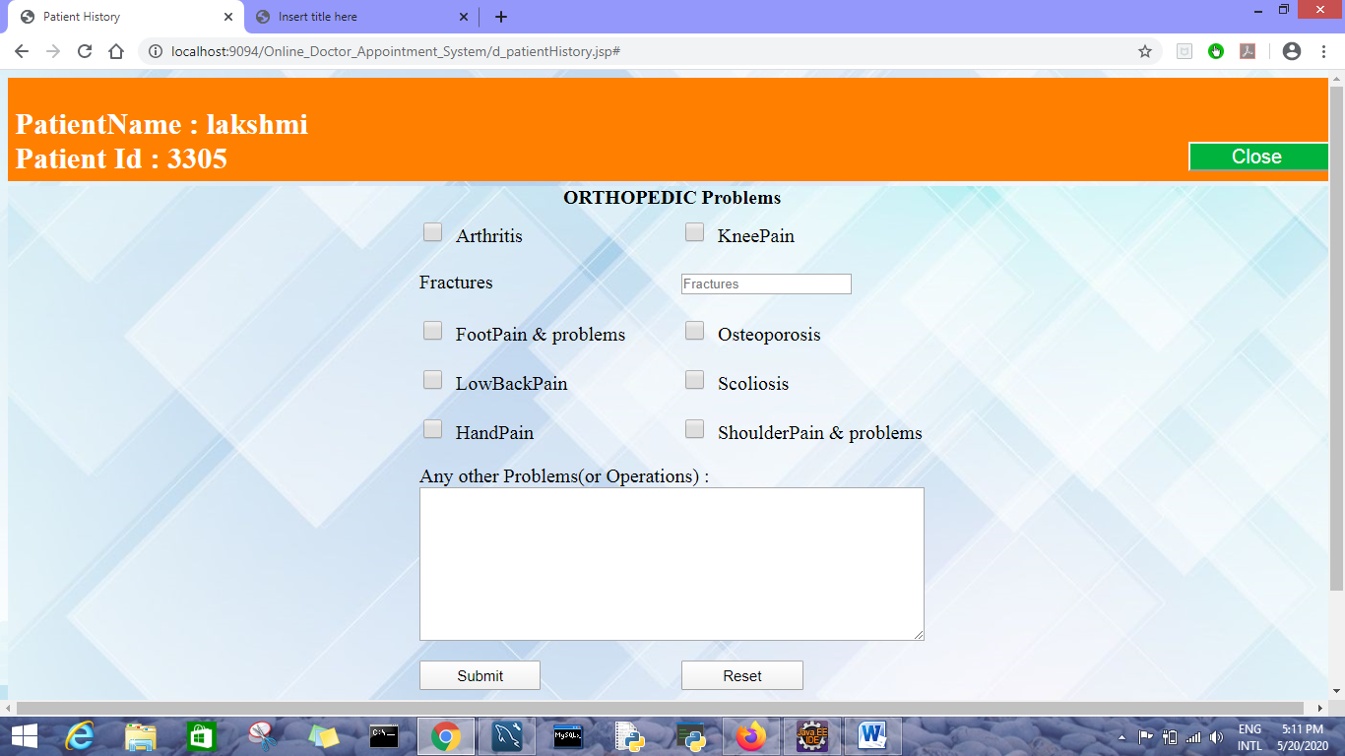

**Cardiologist catalogue when clicks on Add details button**

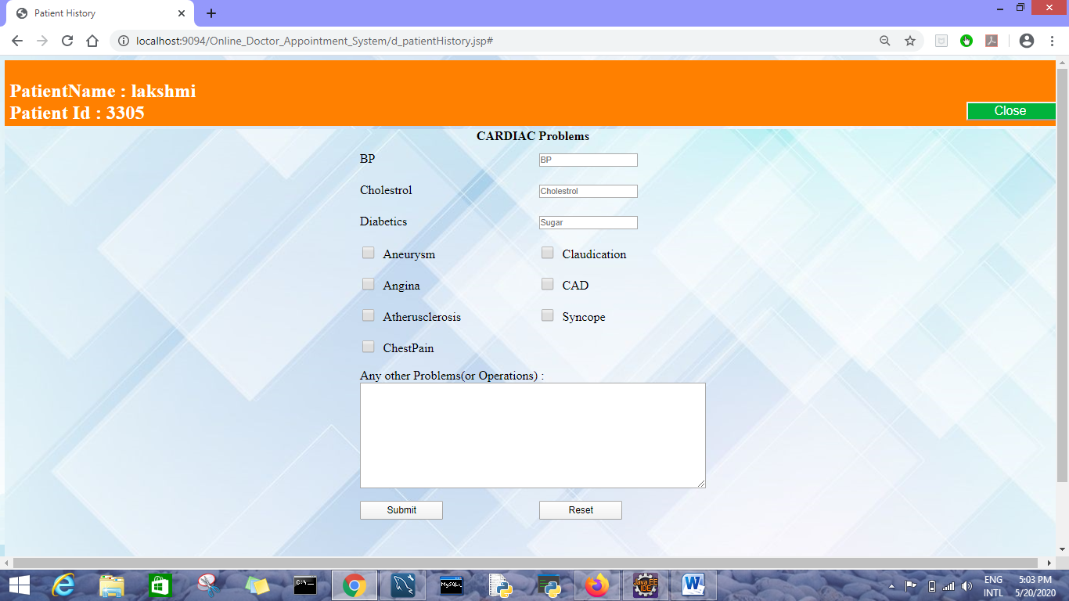

**ENT Doctor catalogue when clicks on Add details button** 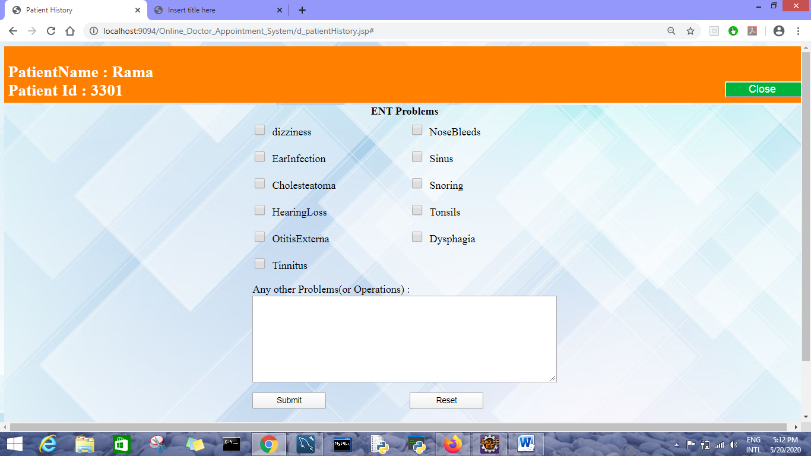

**Dermatologist catalogue when clicks on Add details button**

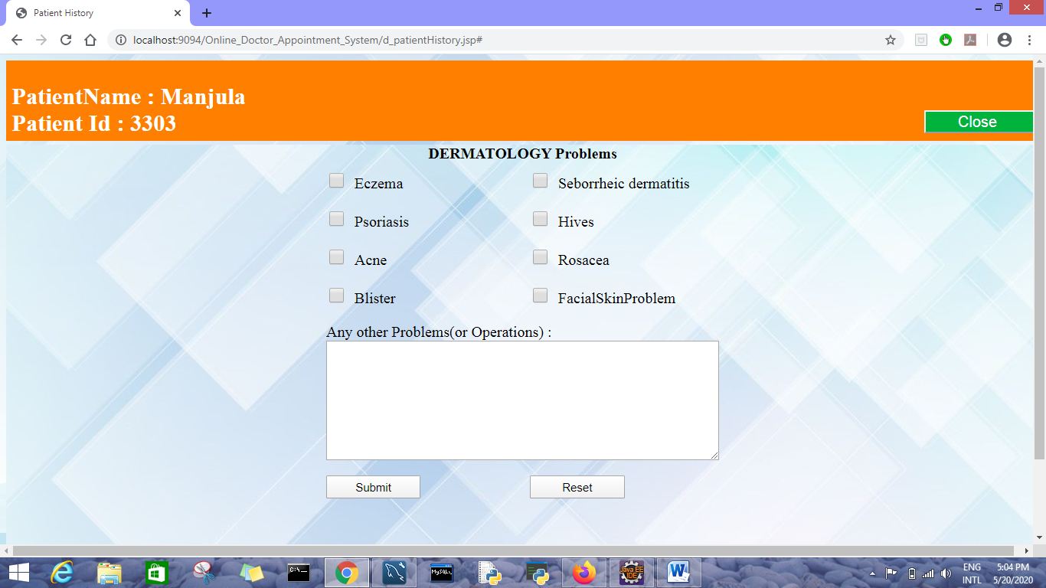

**Psychologist catalogue when clicks on Add details button** 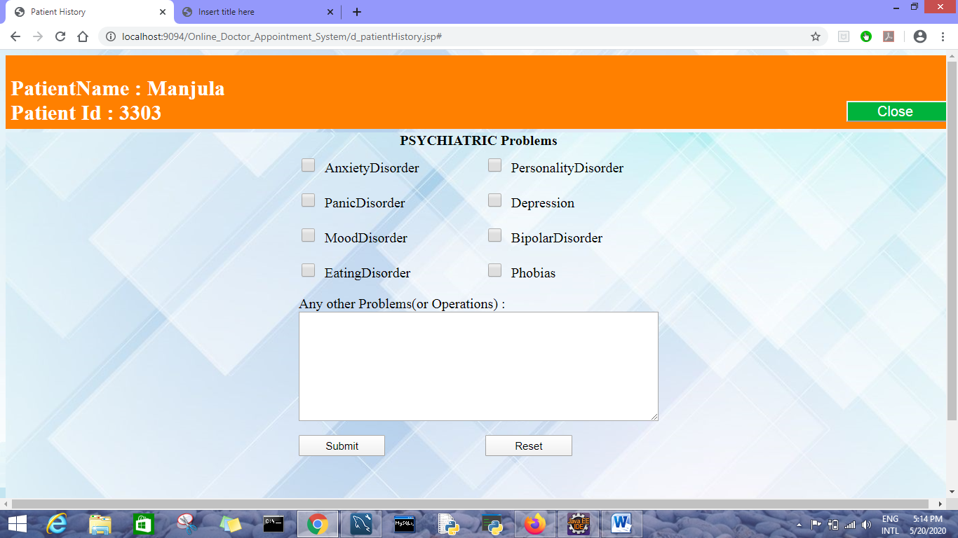

**Patient reports page in doctor portal**

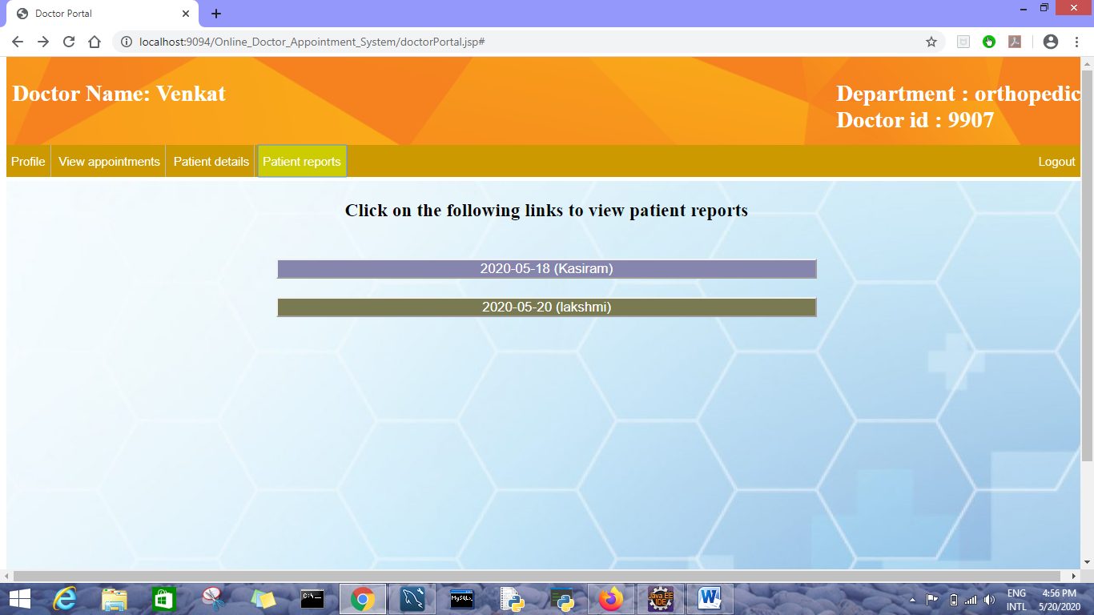

**Reports and prescription page in doctor portal**

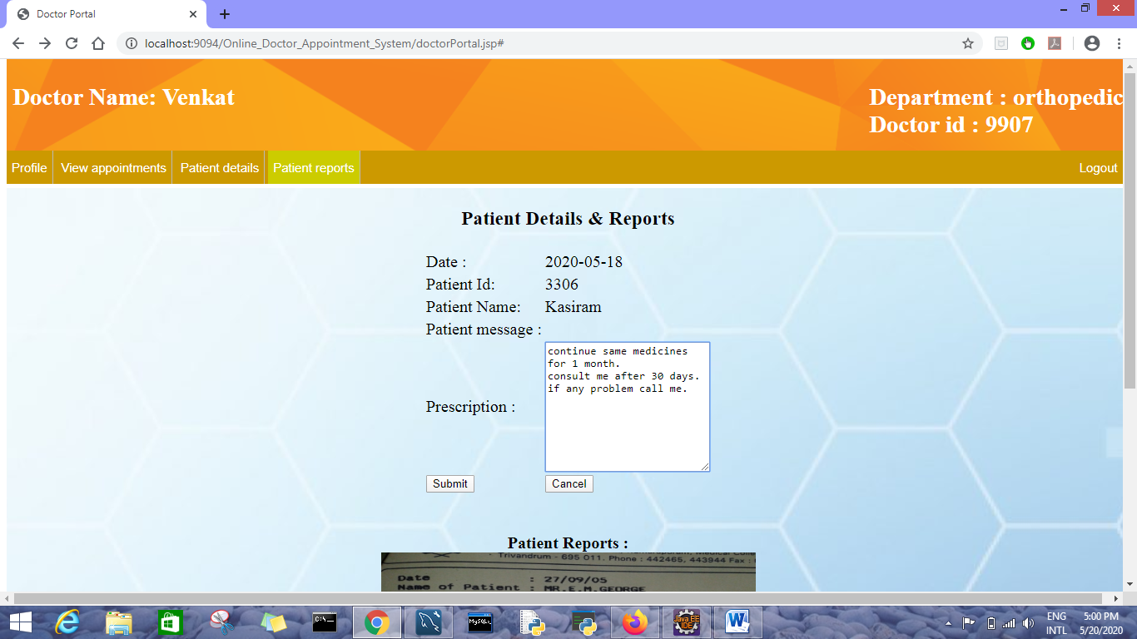

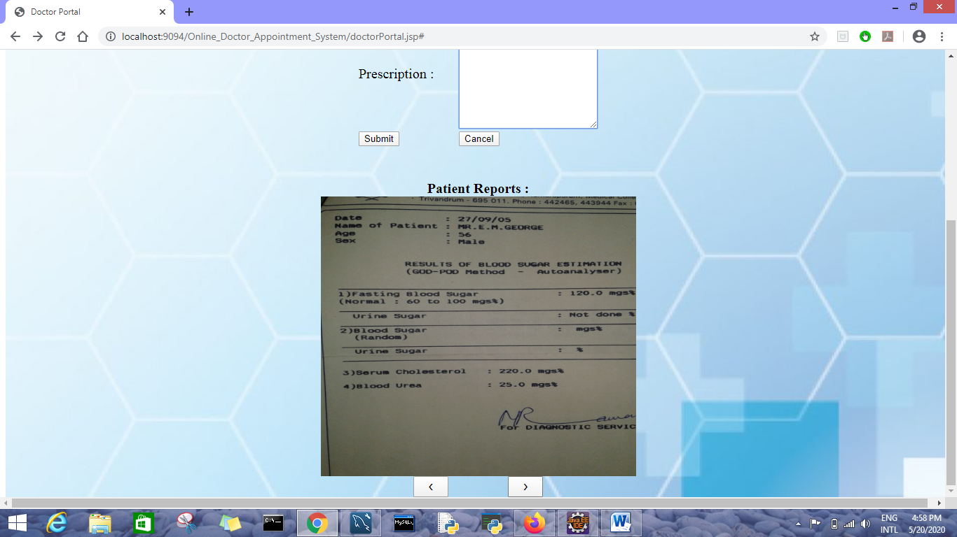

**2)Patient Module**

**Login Page**

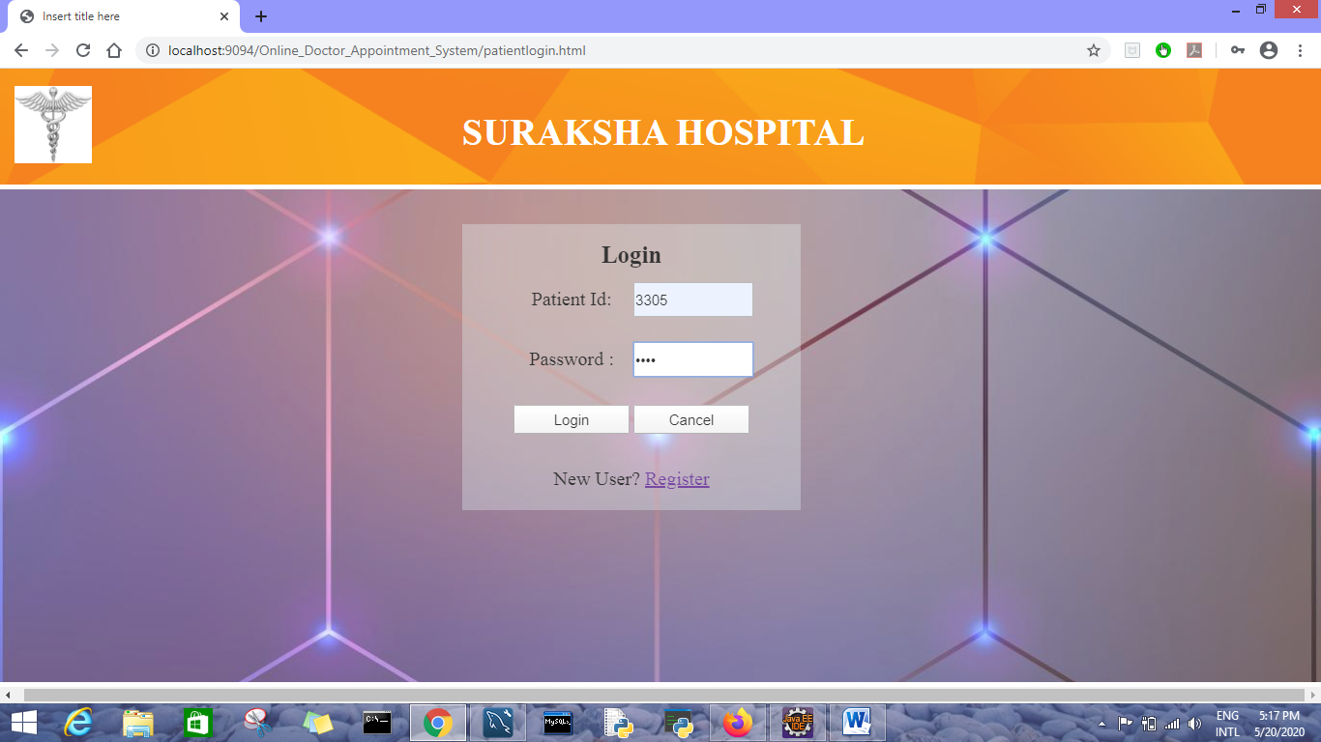

**Patient’s Registration page**

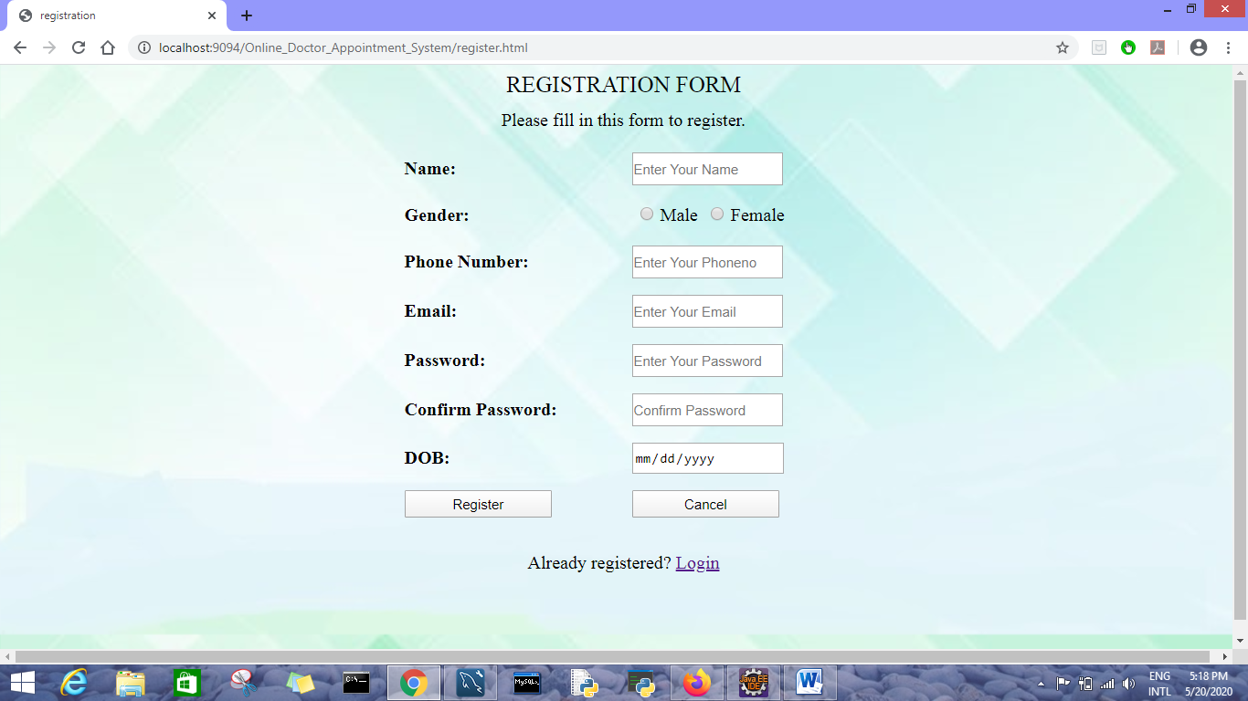

**Patient portal**

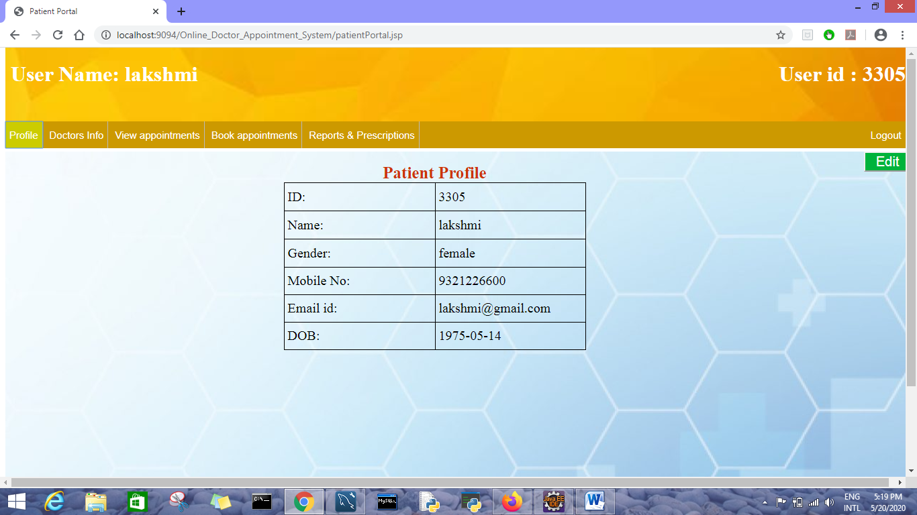

**Patient’s profile edit page**

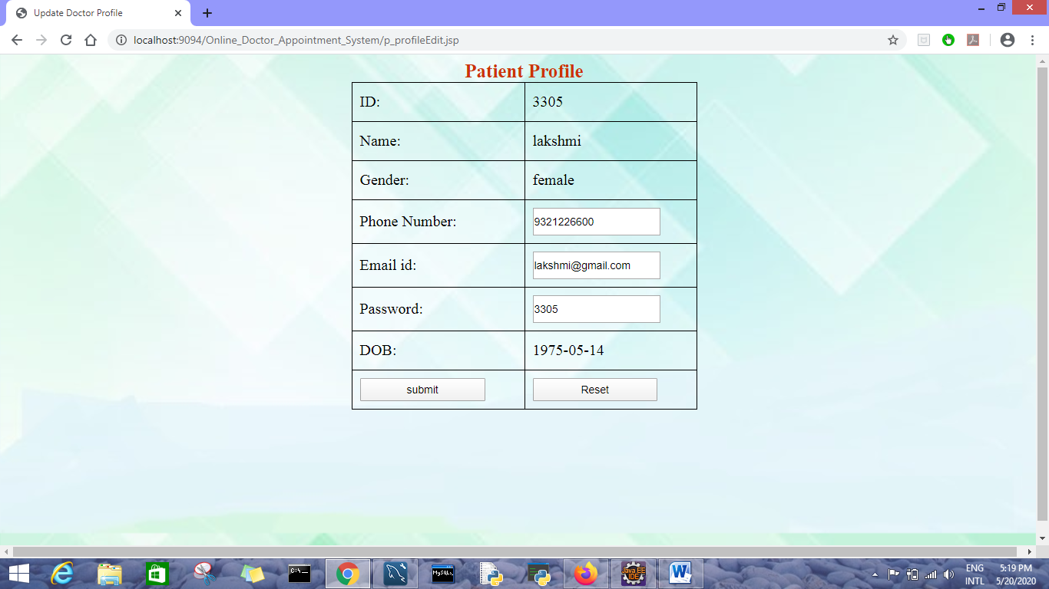

**Doctors information in patient portal**

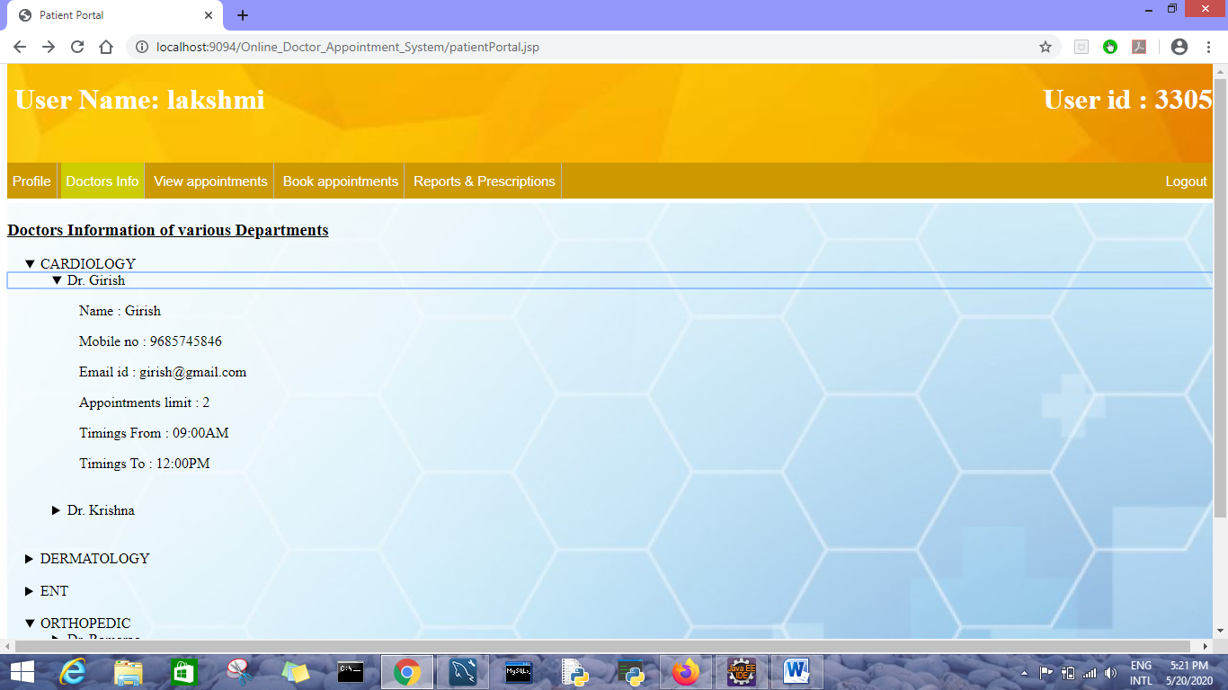

**View appointments page in patient portal**

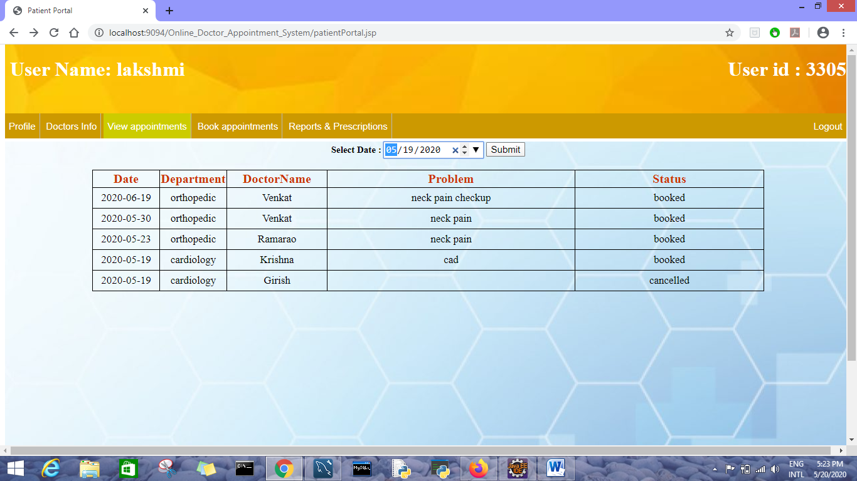

**View appointments page of specific date(if the details are of past history cancel button is not shown)**

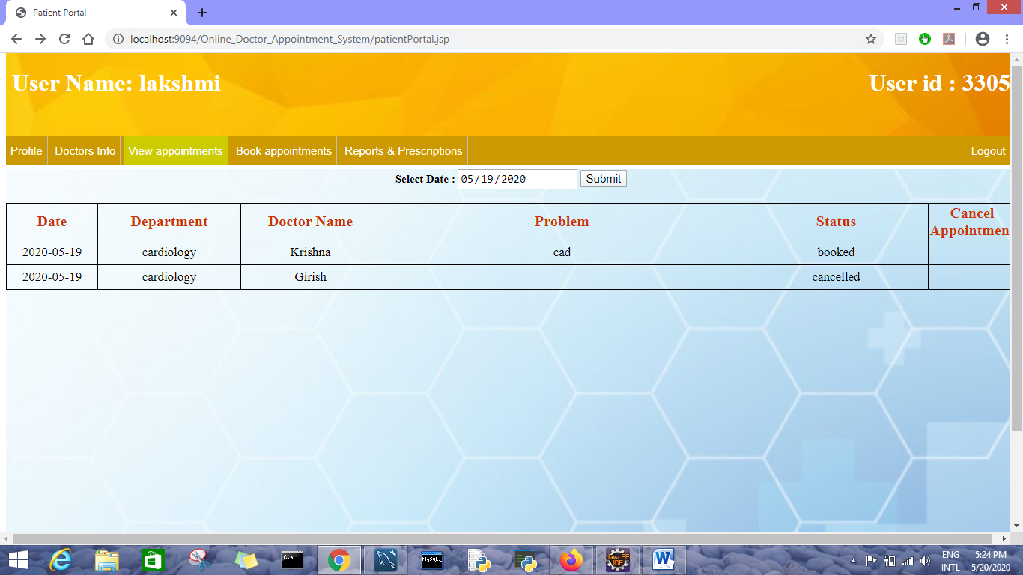

**Booking an appointment page**

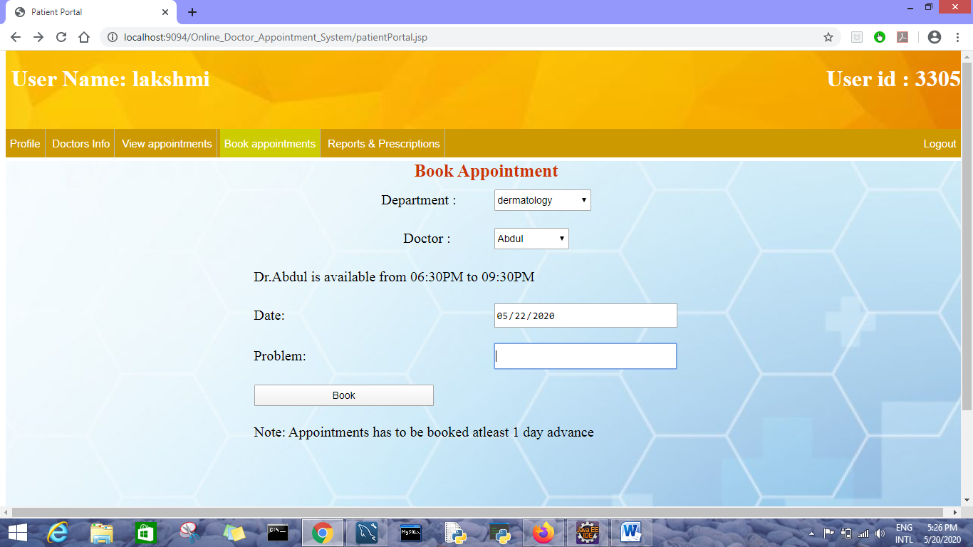

**Reports and prescription page**

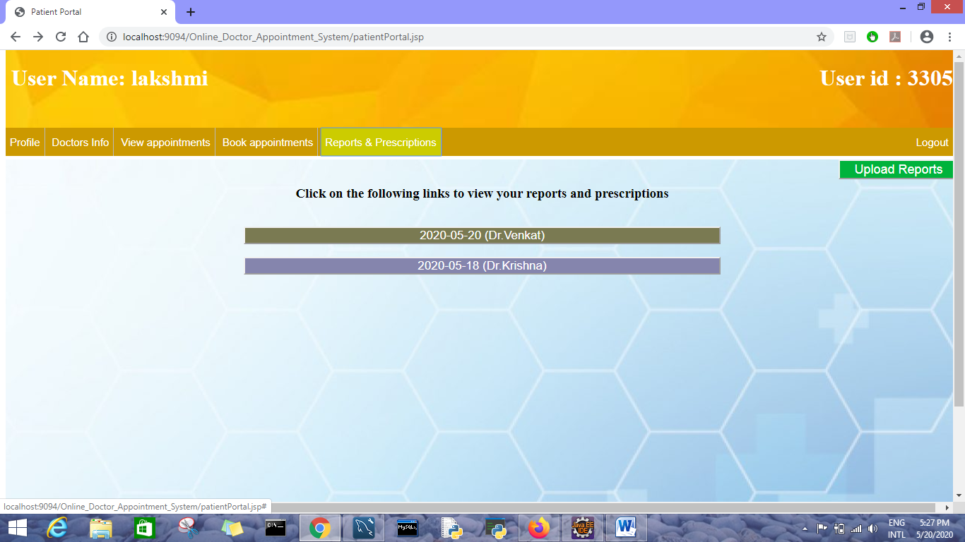

**Click on the link to view prescription**

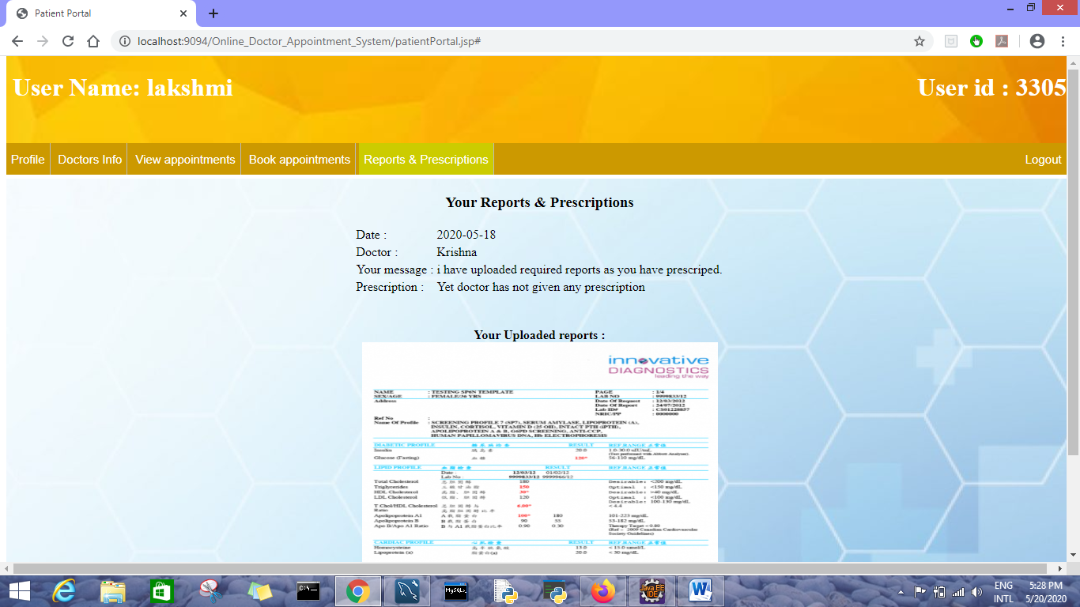

**Upload reports page**

